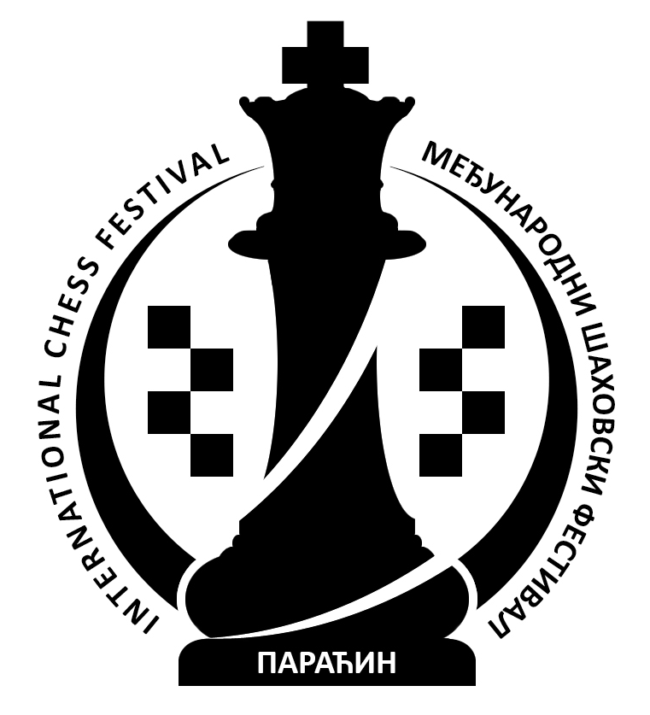

5th International Chess Festival "Sport Summer 2012"
Paraćin, hotel "Petrus" July, 6th-13th 2012.

www.paracinchess.rs

FESTIVAL REGULATIONS

- Youth Chess Club "Paraćin" and Chess Federation of Central Serbia are organizers of
5th International Chess Festival "SPORT SUMMER 2012" on July 6th-13th 2012. The Festival consists of International Championship of Central Serbia (OPEN A and OPEN B) and 8th Memorial Rapid Tournament "Uroš Dinić". Official web site is: www.paracinchess.rs
- International Championship of Central Serbia – OPEN A is open tournament where right to participate is given to all interested chess players rated higher then 2100. Organizer is allowed to include certain number of players with lower rating.
- International Championship of Central Serbia – OPEN B is open tournament where right to participate is given to all interested chess players rated lower or equal to 2100.
- 8th Memorial Rapid Tournament "Uroš Dinić" is open rapid tournament where right to participate is given to all interested chess from Serbia and foreign countries.
- Festival will be held in hotel "Petrus" in Paraćin. Opening Ceremony of the Festival will happen on July 6th at 4⁰⁰ pm, afterwards first round of International Championship of Central Serbia will start.
- All tournaments will be played in 9 rounds – FIDE pairing system. For OPEN A, the rate of play will be 90 minutes for 40 moves plus 30 minutes with 30 seconds increament per move, starting from first move. For OPEN B, the rate of play will be 90 minutes with 30 seconds increament per move, starting from first move. For 8th Memorial Rapid Tournament "Uroš Dinić" the rate of play will be 15 minutes per player.
- Schedule:
Opening Ceremony Friday July 6th 4⁰⁰ pm
1st round Friday July 6th 4³⁰ pm
2nd round Saturday July 7th 9³⁰ am
3rd round Saturday July 7th 4³⁰ pm
8th Memorial Rapid Tournament "Uroš Dinić" Sunday July 8th 10⁰⁰ am
4th round Monday July 9th 4³⁰ pm
5th round Tuesday July 10th 9³⁰ am
6th round Tuesday July 10th 4³⁰ pm
7th round Wednesday July 11th 4³⁰ pm
8th round Thursday July 12th 4³⁰ pm
9th round Friday July 13th 9³⁰ am
Closing Ceremony and rewarding Friday July 13th 3⁰⁰ pm
- Organizer has provided total prize fund of 800.000 dinars.
- For International Championship of Central Serbia – OPEN A organizer has provided 12 regular and 6 special money prizes in total amount of 580.000 dinars.
Regular prizes:
150.000, 100.000, 70.000, 50.000, 40.000, 30.000, 25.000, 20.000, 15.000, 12.000 and 2x10.000 din.
Special prizes:
- the best female player 8.000 din.
- the best veteran player (born 1952. and earlier) 8.000 din.
- the best playern born 1994. and younger 8.000 din.
- the best local player 8.000 din.
- the best player rated lower then 2200 8.000 din.
- the best player in rating group 2201-2000 8.000 din.
For International Championship of Central Serbia – OPEN B organizer has provided 12 regular
and 4 special money prizes in total amount of 165.000 dinars.
Regular prizes:
35.000, 25.000, 20.000, 15.000, 12.000, 10.000, 8.000, 6.000, 2 x 5.000 and 2 x 4.000 din.
Special prizes:
- the best female player 4.000 din.
- the best veteran player (born 1952. and earlier) 4.000 din.
- the best playern born 1994. and younger 4.000 din.
- the best unrated player 4.000 din.
For 8th Memorial Rapid Tournament "Uroš Dinić" organizer has provided 10 regular and 6 special
money prizes in total amount of 55.000 dinars.
Regular prizes:
13.000, 10.000, 7.000, 5.000, 4.000, 3.000, 2.500, 2.000, 1.500 and 1.000 dinars
Special prizes:
- the best female player 1.000 din.
- the best veteran player (born 1952. and earlier) 1.000 din.
- the best playern born 1994. and younger 1.000 din.
- the best local player 1.000 din.
- the best player rated lower then 2000 1.000 din.
- the best player in rating group 2001-2200 1.000 din.
On International Championship of Central Serbia - OPEN A regular prizes will be given
according to HORT criteria and special prizes will be given according to Final stnadings. On
International Championship of Central Serbia - OPEN B and on 8th Memorial Rapid Tournament "Uroš
Dinić" all prizes will be given according to Final stnadings.
One player is not allowed to win more then one prize on each tournament. If a player wins special
prize which is higher then the amount of his regular prize, his regular prize will be equaly distributed
among the players of the same point group.
- If at the end of the tournament two or more players are tied for the same rank, the following tie-break methods shall be applied by order:
- Middle Bucholz, lowest ranked player excluded,
- Progress,
- Greater number of wins and
- Draw
- Festival Chief Arbiter is IA Nebojša Baralić. Deputy Arbiters are FA Saša Jevtič, FA Nataša Savić, FA Hristo Velchev and Regional arbiters Tanja Stojković and Nebojša Radosavljević. Arbiter in charge for computer parinings is IA Boban Milojević. Festival Director is Radoje Marinković.
- Festival will be played according to FIDE Laws of Chess, including changes valid from July 1st 2009.
- Decicions of Chief arbiter are final.
- It is not possible to delay games in any round. According to FIDE Laws of Chess, including changes valid from July 1st 2009 it is not allowed to be late for any round. Those players who are late will lose their games by forfeit, except when Chief Arbiter makes different decision.
- It is not allowed to have draw by agreement in less then 20 moves, except in special cases approved by Chief Arbiter.
- Analyzing is not allowed in the playing hall.
- It is strictly forbidden to bring a mobile phone, not authorized by the chief arbiter, into the playing hall. If a player's mobile phone rings in the playing venue during play, that player shall lose the game by forfeit according the Laws of Chess.
- On International Championship of Central Serbia (OPEN A and OPEN B) players are obliged to write moves to the end of the game. Score sheet has to be filled correctly. Players are obliged to submit original form to the arbiter and to keep copy.
- These Regulations are prescribed by the Organizer and it will be announced in the playing hall. By making first move all players will confirm that they agree whit all articles of this Regulations.

Paraćin July 6th 2011. Organising Committee

