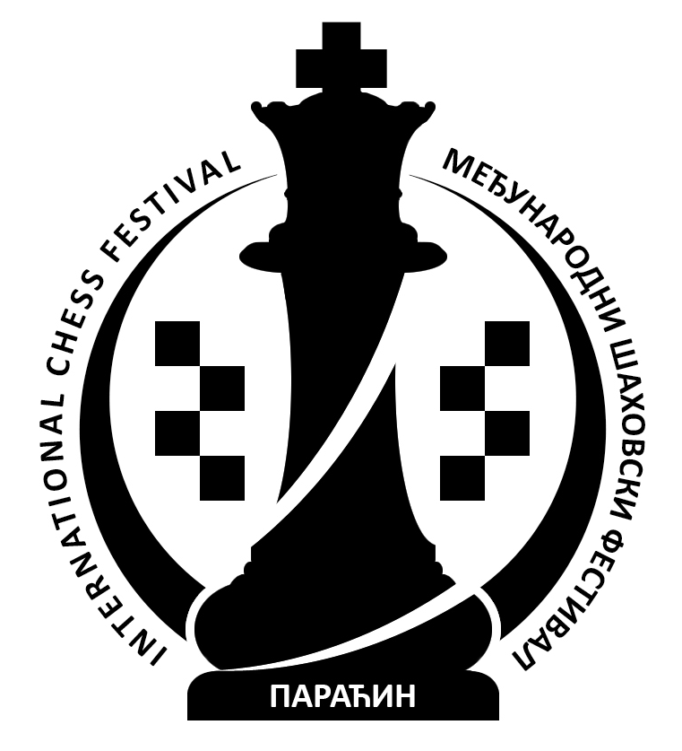

7th International Chess Festival "Sport Summer 2014"
Paraćin, hotel "Petrus" July, 4th-11th 2014.

www.paracinchess.rs

FESTIVAL REGULATIONS

- Youth Chess Club "Paraćin" and Chess Federation of Central Serbia are organizers of
7th International Chess Festival "SPORT SUMMER 2014" on July 4th-11th 2014. The Festival consists of International Championship of Central Serbia 2014 (OPEN A and OPEN B) and 10th Memorial Rapid Tournament "Uroš Dinić". Official web site is: www.paracinchess.rs
- International Championship of Central Serbia 2014 – OPEN A is open tournament where right to participate is given to all interested chess players rated higher than 2100. Organizer is allowed to include certain number of players with lower rating.
- International Championship of Central Serbia 2014 – OPEN B is open tournament where right to participate is given to all interested chess players rated lower or equal to 2100.
- 10th Memorial Rapid Tournament "Uroš Dinić" is open rapid tournament where right to participate is given to all interested chess players from Serbia and foreign countries.
- Festival will be held in hotel "Petrus" in Paraćin. Opening Ceremony of the Festival will happen on July 4th at 4¹⁵ pm, afterwards first round of International Championship of Central Serbia 2014 will start.
- All tournaments will be played in 9 rounds – FIDE pairing system. For OPEN A and OPEN B, the rate of play will be 90 minutes with 30 seconds increament per move, starting from first move. For 10th Memorial Rapid Tournament "Uroš Dinić" the rate of play will be 15 minutes per player.
- Schedule:
Opening Ceremony Friday July 4th 4¹⁵ pm
1st round Friday July 4th 4³⁰ pm
2nd round Saturday July 5th 9³⁰ am
3rd round Saturday July 5th 4³⁰ pm
8th Memorial Rapid Tournament "Uroš Dinić" Sunday July 6th 10⁰⁰ am
4th round Monday July 7th 4³⁰ pm
5th round Tuesday July 8th 9³⁰ am
6th round Tuesday July 8th 4³⁰ pm
7th round Wednesday July 9th 4³⁰ pm
8th round Thursday July 10th 4³⁰ pm
9th round Friday July 11th 9³⁰ am
Closing Ceremony and rewarding Friday July 11th 3⁰⁰ pm
- Organizer has provided total prize fund of 850.000 dinars.
- For International Championship of Central Serbia 2014 – OPEN A organizer has provided 10 regular and 6 special money prizes in total amount of 600.000 dinars.
Regular prizes:
170.000, 110.000, 70.000, 50.000, 40.000, 30.000, 25.000, 20.000, 15.000 and 10.000 din.
Special prizes:
- the best female player 10.000 din.
- the best veteran player (born 1954. and earlier) 10.000 din.
- the best playern born 1996. and younger 10.000 din.
- the best local player 10.000 din.
- the best player rated lower then 2200 10.000 din.
- the best player in rating group 2201-2300 10.000 din.

For International Championship of Central Serbia 2014 – OPEN B organizer has provided 12
regular and 4 special money prizes in total amount of 190.000 dinars.
Regular prizes:
40.000, 30.000, 20.000, 15.000, 12.000, 10.000, 9.000, 8.000, 2 x 7.000 and 2 x 6.000 din.
Special prizes:
- the best female player 5.000 din.
- the best veteran player (born 1954. and earlier) 5.000 din.
- the best player born 1996. and younger 5.000 din.
- the best local player 5.000 din.

For 10th Memorial Rapid Tournament "Uroš Dinić" organizer has provided 10 regular and 4 special
money prizes in total amount of 60.000 dinars.
Regular prizes:
15.000, 11.000, 8.000, 6.000, 5.000, 4.000, 3.000, 2.000, 1.000 and 1.000 dinars
Special prizes:
- the best female player 1.000 din.
- the best veteran player (born 1954. and earlier) 1.000 din.
- the best playern born 1996. and younger 1.000 din.
- the best local player 1.000 din.
On International Championship of Central Serbia 2014 - OPEN A regular prizes will be given according to HORT criteria, but only for players with score of 6½ points and higher. Other regular money prizes and special prizes will be given according to Final standings. On International Championship of Central Serbia 2014 - OPEN B and on 10th Memorial Rapid Tournament "Uroš Dinić" all prizes will be given according to Final standings. One player is not allowed to win more then one prize on each tournament.
- If at the end of the tournament two or more players are tied for the same rank, the following tie-break methods shall be applied by order:
- Middle Bucholz, lowest ranked player excluded,
- Progress,
- Greater number of wins and
- Draw
- Festival Chief Arbiter is IA Saša Jevtić. Deputy Arbiters are IA Nebojša Baralić and IA Boban Milojević for OPEN A and FA Nataša Savić and FA Nebojša Radosavljević for OPEN B. Arbiters are NA Tanja Stojković and CA Dejan Miletić. Festival Chief Arbiter will be in charge for computer parings. Festival Director is Radoje Marinković.
- Festival will be played according to FIDE Laws of Chess, including changes valid from July 1st 2014.
- Decicions of Chief arbiter are final.
- It is not possible to delay games in any round. According to FIDE Laws of Chess, including changes valid from July 1st 2014. it is not allowed to be late for any round. Those players who are late will lose their games by forfeit, except when Chief Arbiter makes different decision.
- It is not allowed to have draw by agreement in less then 20 moves, except in special cases approved by Chief Arbiter.
- Analyzing is not allowed in the playing hall.
- It is strictly forbidden to bring a mobile phone, not authorized by the chief arbiter, into the playing hall. If a player's mobile phone rings or makes any other sound in the playing venue during play, that player shall lose the game by forfeit according the Laws of Chess.
- On International Championship of Central Serbia 2014 (OPEN A and OPEN B) players are obliged to write moves to the end of the game. Score sheet has to be filled correctly. Players are obliged to submit original form to the arbiter and to keep copy.
- These Regulations are prescribed by the Organizer and will be announced in the playing hall. By making first move all players will confirm that they agree whit all articles of this Regulations.

Paraćin, July 4th 2014. Organising Committee

